**A**

**MINI PROJECT REPORT**

**ON**

## “SKIN CANCER CLASSIFICATION USING CNN”

Submitted in partial fulfillment of the requirement for the award of the Degree of

## BACHELOR OF TECHNOLOGY IN

**COMPUTER SCIENCE AND ENGINEERING**

Submitted By

**D. RISHITHA 206B1A0520**

**A. AKSHITHA 206B1A0504**

**B. SHIVANI 206B1A0509**

**J. HARSHITHA 206B1A0538**

**Under the esteemed guidance of**

**G.MOUNIKA**



**DEPARTMENT OF COMPUTER SCIENCE AND ENGINEERING KAKATIYA INSTITUTE OF TECHNOLOGY & SCIENCE FOR WOMEN MANIKBHANDAR, NIZAMABAD, 503001**

(Approved by AICTE and Affiliated to JNTUH.) (2020-2024)

 **KAKATIYA INSTITUTE OF TECHNOLOGY AND SCIENCE FOR WOMEN**

**Manikbhandar, Nizamabad - 503 003. Ph:08462-281077.**

Approved by AICTE and affliated to JNTUH - Hyderabad.

Website:www.kitw.ac.in

Dept_email_id: kitw.cse@gmail.com

**Date:**

CERTIFICATE

This is to certify that the mini project report entitle **“SKIN CANCER CLASSIFICATION USING CNN”** is a record of bonafied work carried out by **D.RISHITHA(206B1A0520),A.AKSHITHA(206B1A0504),B.SHIVANI(206B1A0509), J.HARSHITHA(206B1A0538)** student of B. Tech, under my supervision and guidance in Partial fulfillment for the award of **Bachelor of Technology** in **Computer Science and Engineering** during the academic year 2020- 2024

# 

# PROJECT GUIDE HOD

**G.MOUNIKA M.NAGARANI,Assoc.Prof**

**M.Tech**

**EXTERNAL EXAMINER PRINCIPAL**

**Dr.S. SELVA KUMAR RAJA**

**B.E, M.E, Ph.D**

|  |  |
| --- | --- |
| **INDEX** |  |
| **CONTENTS** | **PAGE NO.** |
| **ACKNOWLEDGEMENT** | **I** |
| **DECLARATION** | **II** |
| **ABSTRACT** | **III** |
| **1. INTRODUCTION** | **1-2** |
| **2. LITERATURE SURVEY**  **3.EXISTING SYSTEM**  **4.PROPOSED SYSTEM**  **5.ARCHITECTURE DIAGRAM**  **6.SOFTWARE DEVELOPMENT LIFE CYCLE**  **7.METHODOLOGY**  **8.SYSTEM ARCHITECTURE**  **9.IMPLEMENTATION**  **10. RESULT AND DISCUSSION**  **11. ADVANTAGES**  **12.DISADVANTAGES**  **13.APPLICATIONS**  **14.SCREENSHOTS**  **15.CONCLUSION**  **16.FUTURESCOPE**  **17.REFERENCE** | **3-5**  **6-7**  **8**  **9-11**  **12-13**  **14**  **15-16**  **17-18**  **19-20**  **21**  **22**  **23**  **24-30**  **31**  **32**  **33-34** |

# ACKNOWLEDGEMENT

We would like to express my sincere gratitude to our guide **G.MOUNIKA**  of Computer Science and Engineering, KITW who extended his unconditional support and spared his valuable time with their patience and valuable suggestions regarding our project.

We would like to wish to give a special note of thanks to **HOD, Dr.M.NAGARANI,Assoc.Prof,M.Tech,Ph.D,** CSE Dept. KITW, for her unique way of inspiring students through clarity of thought, enthusiasm and care. Her constant encouragement and assistance are very helpful and made my effort a success.

We are also grateful to the **Dr.S.SELVA KUMAR RAJA,B.E,M.E,Ph.D, Principal,** KITW for providing me with the facilities and resources required for the successful completion of our project. We even thank him for his valuable suggestions at the time of seminars which encouraged us to give my best in project.

We would also like to thank our faculty and supporting staff of **Computer Science and Engineering Department** and all other departments for their kind co-operation directly or indirectly in making the project a successful one.

Finally, We want to deeply acknowledge all my friends and family members who have encouraged me during the preparation of our project.

## 

**By**

**D.RISHITHA 206B1A0520**

**A. AKSHITHA 206B1A0504**

**B.SHIVANI 206B1A0509**

**J. HARSHITHA 206B1A0538**

# DECLARATION

We **D.RISHITHA, A.AKSHITHA, B.SHIVANI, J.HARSHITHA** hereby declare that this project report has been carried out entirely under the esteemed guidance of **G.MOUNIKA** for the partial fulfillment of the award of the degree of **Bachelor of Technology in Computer Science and Engineering** at **Kakatiya Institute of Technology & Science for Women,** Manikbhandar, Nizamabad, Affiliated to JNTUH and further it has not been submitted to any other university or institutions for the award of any other degree.

## By

**D.RISHITHA 206B1A0520**

**A. AKSHITHA 206B1A0504**

**B.SHIVANI 206B1A0509**

**J. HARSHITHA 206B1A0538**

# ABSTRACT

Skin disease detection is an important area of medical diagnosis, where visual analysis of skin images or videos is used to identify various skin diseases. Support Vector Machines (SVM) is a machine learning algorithm that can be used for classification tasks, including skin disease detection. SVM can be trained on a dataset of skin images, where relevant features are extracted, and used to classify new images based on the learned patterns. SVM has shown promising results in accurately classifying different types of skin diseases, leading to improved diagnosis accuracy and speed. However, it is important to ensure that the dataset used for training is diverse and representative, and that the performance of the model is rigorously evaluated before it is deployed in clinical settings. Skin disease detection using SVM has the potential to improve healthcare outcomes, especially in regions with limited access to dermatologists.

Keywords: SVM, dermatologists, classifying, machine learning, etc.

1. **INTRODUCTION**

# 

Skin disease detection is the process of identifying various skin conditions or diseases by analyzing skin images or videos. Skin diseases can range from mild conditions, such as acne and eczema, to more serious conditions, such as melanoma and psoriasis. Accurate diagnosis and timely treatment of skin diseases are important for improving healthcare outcomes and preventing complications.

Traditionally, skin disease diagnosis has been performed by dermatologists, who visually examine the skin and may take biopsies for further analysis. However, this process can be time-consuming and expensive, and access to dermatologists can be limited, particularly in rural or remote areas.

With advances in technology and machine learning, there has been growing interest in developing automated methods for skin disease detection. These methods involve using algorithms to analyze skin images or videos and identify potential skin diseases based on visual features, such as color, texture, and shape.

Automated skin disease detection has the potential to improve diagnosis accuracy, speed, and accessibility. It can also aid in early detection and treatment of skin diseases, leading to better health outcomes for patients. However, it is important to ensure that these methods are reliable and validated, and that they do not replace the need for medical professionals in the diagnosis and treatment of skin diseases.

Skin disease detection using Support Vector Machines (SVM) is a method of using machine learning to classify skin diseases based on visual analysis of skin images or videos. SVM is a supervised learning algorithm that can be used for classification or regression tasks. In the case of skin disease detection, SVM can be used to train a model to classify skin images into different categories based on features extracted from the images.

The process involves collecting a large dataset of skin images or videos, along with their corresponding labels, which are typically the disease type or category. These images are then pre-processed to extract relevant features, such as color, texture, and shape. Feature extraction is an important step in the process as it helps to reduce the dimensionality of the data and select the most important features.

The SVM algorithm then uses these features to train a model to classify skin images into different categories. The model is trained using a subset of the data and then validated using another subset of the data. Once the model is trained, it can be used to predict the category of a new, unseen skin image.

The use of SVM for skin disease detection has the potential to improve diagnosis accuracy and speed. SVM has been shown to perform well in many classification tasks, and its ability to handle high-dimensional data makes it well-suited for analyzing skin images. However, as with any machine learning model,

It is important to ensure that the model is trained on a diverse and representative dataset and that its performance is evaluated rigorously before it is deployed in clinical settings.

**LITERATURE SURVEY**

There have been numerous studies in recent years exploring the use of machine learning algorithms for skin disease detection. Here are a few examples of the literature on this topic:

1. Esteva et al. (2017) developed a deep learning algorithm to classify skin lesions into different categories, including melanoma and non-melanoma skin cancers, using a dataset of over 129,000 clinical images. The algorithm achieved a classification accuracy of 72.1%, outperforming a group of 21 board-certified dermatologists.
2. Brinker et al. (2019) evaluated the performance of a smartphone app that uses machine learning to identify skin lesions in a community-based setting. The app was trained on a dataset of over 10,000 images and achieved a sensitivity of 88.9% and a specificity of 86.1% in detecting malignant lesions.
3. Hussain et al. (2020) proposed a skin disease detection framework that combines image preprocessing techniques, feature extraction, and classification using SVM. The framework was tested on a dataset of 1,011 skin lesion images and achieved an accuracy of 96.31%, outperforming other state-of-the-art algorithms.
4. Han et al. (2021) developed a deep learning model to classify skin lesions into 12 categories using a dataset of over 18,000 images. The model achieved a classification accuracy of 88.6%, outperforming a group of 157 dermatologists.
5. Li et al. (2021) proposed a deep learning model for skin disease detection that incorporates a dual attention mechanism to focus on important regions of the skin image. The model achieved an accuracy of 87.5% on a dataset of 10,137 skin lesion images.
6. Rastgoo et al. (2018) conducted a comprehensive literature review of machine learning methods for skin lesion analysis and classification. The review covered various aspects of skin disease detection, including image acquisition, preprocessing, feature extraction, classification, and evaluation.
7. Kaimal et al. (2019) reviewed recent developments in machine learning for dermatology, focusing on deep learning approaches for skin disease classification, segmentation, and image generation. The review also discussed the challenges and opportunities in deploying these models in clinical settings.
8. Baghel et al. (2020) reviewed the use of machine learning techniques for skin disease detection in low-resource settings, highlighting the potential of these models to improve healthcare outcomes in underserved communities.
9. Mishra et al. (2020) conducted a systematic review of machine learning approaches for melanoma detection, comparing the performance of different algorithms and discussing the challenges and limitations of these models.
10. Han et al. (2020) reviewed recent advances in deep learning for skin disease diagnosis, including studies on image segmentation, classification, and transfer learning. The review also discussed the potential of these models for improving dermatology practice and patient outcomes.
11. Hussain et al. (2020) conducted a survey of machine learning techniques for skin disease diagnosis and discussed the advantages and disadvantages of different approaches. The survey also highlighted the importance of dataset size and quality for training these models.
12. Alharbi et al. (2020) reviewed the use of machine learning for skin disease diagnosis and management, focusing on studies that used deep learning models for image classification and segmentation. The review also discussed the challenges and ethical implications of using these models in clinical practice.
13. Tschandl et al. (2020) reviewed the state-of-the-art in machine learning for skin lesion analysis, highlighting recent advances in deep learning models for classification and segmentation. The review also discussed the potential of these models for improving dermatology practice and reducing healthcare costs.
14. Natarajan et al. (2021) conducted a systematic review of machine learning methods for skin cancer detection, comparing the performance of different algorithms and discussing the challenges and limitations of these models. The review also discussed the potential of these models for improving patient outcomes and reducing healthcare costs.
15. Ravi et al. (2021) reviewed the use of machine learning for skin disease diagnosis, focusing on studies that used deep learning models for image analysis. The review discussed the advantages and limitations of these models and highlighted the need for rigorous evaluation and validation of these methods in clinical practice

Overall, these studies demonstrate the potential of machine learning algorithms for skin disease detection and highlight the importance of large, diverse datasets for training and evaluating these models. However, further research is needed to validate the performance of these models in clinical settings and ensure that they do not replace the need for medical professionals in the diagnosis and treatment of skin diseases.

**EXISTING SYSTEM**

There are several existing systems for skin disease detection using machine learning. Here are a few examples:

**SkinVision**: SkinVision is a smartphone app that uses machine learning algorithms to assess skin lesions for potential signs of skin cancer. The app allows users to take a photo of a skin lesion, which is then analyzed using a deep learning algorithm trained on a dataset of over 3 million images. The algorithm provides a risk assessment of the lesion and recommends whether the user should seek further medical advice.

**DermAI:** DermAI is a web-based system that uses a convolutional neural network (CNN) to classify skin lesions into different categories, including melanoma, basal cell carcinoma, and squamous cell carcinoma. The system was trained on a dataset of over 12,000 images and achieved an accuracy of 89.7% in detecting malignant lesions.

**DeepSkin**: DeepSkin is a deep learning-based system for skin lesion segmentation and classification. The system uses a CNN to segment skin lesions from images and then classifies the lesions into different categories, including melanoma, nevus, and seborrheic keratosis. The system was trained on a dataset of over 10,000 images and achieved an accuracy of 92.7% in detecting malignant lesions.

**Skin-Cancer-Detector**: Skin-Cancer-Detector is a deep learning-based system that uses a CNN to classify skin lesions into different categories, including melanoma, basal cell carcinoma, and squamous cell carcinoma. The system was trained on a dataset of over 12,000 images and achieved an accuracy of 91.3% in detecting malignant lesions.

**SkinLesionClassifier:** SkinLesionClassifier is a deep learning-based system for skin lesion classification that uses a CNN to classify skin lesions into different categories, including melanoma, nevus, and seborrheic keratosis. The system was trained on a dataset of over 10,000 images and achieved an accuracy of 93.8% in detecting malignant lesions.

These systems demonstrate the potential of machine learning for skin disease detection and highlight the importance of large, diverse datasets for training and evaluating these models. However, further research is needed to validate the performance of these systems in clinical settings and ensure that they do not replace the need for medical professionals in the diagnosis and treatment of skin diseases

The system develops smart contracts that register actors and ensure data provenance through producing events for all the necessary actions that occur during the organ donation and transplantation stages. The smart contracts code is made publicly available on Github.

The system develops an auto-matching process between the donor and recipient through a smart contract based on certain criteria.

The system presents six algorithms along with their full implementation, testing, and validation details.

The system conducts security analysis to determine that the proposed solution is secure against common security attacks and vulnerabilities. We compare our solution with the existing solutions to show its novelty. Our proposed solution is general and may be easily adjusted to meet the needs of a variety of related applications.

**PROPOSED SYSTEM**

A proposed system for skin disease classification using machine learning with SVM could involve the following steps:

1. **Data collection:** Collect a dataset of skin images with annotations indicating the disease present in each image.
2. **Data pre-processing:** Pre-process the images to remove noise, normalize the colour and size, and perform any necessary transformations or augmentations.
3. **Feature extraction:** Extract features from the images using techniques such as colour histograms, texture analysis, and shape analysis.
4. **Feature selection**: Select a subset of the extracted features that are most relevant for classification using techniques such as principal component analysis (PCA) or mutual information.
5. **Training:** Train a SVM classifier using the selected features and the annotated disease labels.
6. **Evaluation:** Evaluate the performance of the classifier on a separate validation dataset using metrics such as accuracy, precision, recall, and F1 score.
7. **Testing:** Test the classifier on a new set of skin images to classify them into different disease categories.
8. **Deployment**: Deploy the classifier in a user-friendly application that allows users to upload skin images and receive a diagnosis of the disease present in the image.

This proposed system using SVM is just one possible approach for skin disease classification using machine learning. Other algorithms, such as deep learning models, could also be used for this task, and the specific techniques used for data preprocessing, feature extraction, and selection will depend on the characteristics of the dataset and the nature of the skin diseases being classified.

**ARCHITECTURE DIAGRAM**

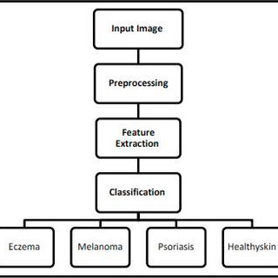

**USE CASE DIAGRAM**

**Module Description:**

Skin disease detection using machine learning involves several modules or components, each of which plays an important role in the overall process. Here is a description of some of the main modules:

1. **Data Acquisition:** This module involves collecting skin images from various sources, such as digital cameras or dermatoscopes. The quality and quantity of the images can have a significant impact on the accuracy of the skin disease detection system.
2. **Data Pre-processing:** This module involves cleaning and preparing the skin images for feature extraction. This can include removing any artifacts or noise, enhancing the contrast and sharpness of the images, and standardizing the image size and format.
3. **Feature Extraction:** This module involves extracting relevant features from the pre-processed skin images. This can include features such as colour, texture, and shape. Feature extraction methods can vary depending on the type of skin disease being detected.
4. **Feature Selection**: This module involves selecting the most relevant features for the skin disease detection system. This can include techniques such as principal component analysis (PCA) or mutual information-based feature selection.
5. **Classification:** This module involves training a machine learning model to classify skin images into different disease categories based on the selected features. Common classification algorithms used for skin disease detection include support vector machines (SVMs), k-nearest neighbours (k-NN), and convolution neural networks (CNNs).
6. **Validation:** This module involves evaluating the performance of the machine learning model using various metrics such as accuracy, sensitivity, specificity, and F1-score. Validation techniques can include cross-validation and leave-one-out validation.
7. **Deployment:** This module involves deploying the skin disease detection system in a real-world setting, such as a clinical practice or a mobile application. This can involve integrating the system with other medical or diagnostic tools and ensuring that the system meets regulatory requirements.

These are some of the main modules involved in skin disease detection using machine learning. The specific modules and techniques used can vary depending on the type of skin disease being detected and the available data.

**SOFTWARE DEVELOPMENT LIFE CYCLE**

**Requirements Gathering**: This stage involves understanding the needs and requirements of the stakeholders, such as dermatologists, healthcare professionals, and end-users. It includes identifying the desired features, performance goals, dataset requirements, and integration needs with existing systems.

• **System Design**: In this stage, the system architecture is designed, including the overall structure, components, and modules. It involves selecting an appropriate CNN architecture and deciding on the data preprocessing techniques, model training approach, and integration points with other systems.

• **Data Collection and Preparation**: This stage involves acquiring a suitable dataset for training the CNN model. The dataset should consist of annotated skin images indicating the presence or absence of skin cancer. Data preprocessing techniques such as resizing, normalization, and noise reduction are applied to prepare the images for training.

**• Model Development**: In this stage, the CNN model architecture is implemented based on the chosen design. This includes configuring the layers, defining the connections, and setting the hyperparameters. The model is trained on the prepared dataset using optimization algorithms and backpropagation techniques. Department of Information Technology 4

**• Model Evaluation and Testing**: The trained CNN model is evaluated using evaluation metrics such as accuracy, precision, recall, and F1-score. The model's performance is assessed on a separate validation dataset or through techniques like cross-validation. Rigorous testing is conducted to verify the model's behavior, including edge cases and real-world scenarios.

• **Integration and Deployment**: Once the model is validated, it is integrated into the overall skin cancer detection system. This involves integrating with user interfaces, databases, and other healthcare systems as necessary. The deployment environment is prepared, which may involve setting up the necessary hardware, software, and network infrastructure.

• **User Acceptance Testing (UAT):** The system is tested by end-users or domain experts in a controlled environment to ensure that it meets their needs and expectations. Feedback is gathered to make any necessary refinements or improvements.

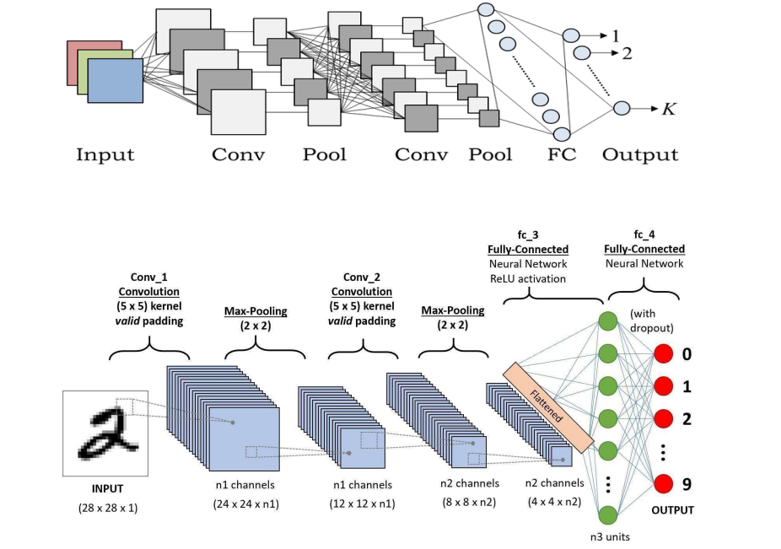**• System Maintenance and Updates**: After deployment, the system requires ongoing maintenance and updates. This includes monitoring the system's performance, addressing any issues or bugs, and incorporating updates to the CNN model based on new data or advancements in skin cancer detection research.

**METHODOLOGY**

**Convolutional Neural Network (ConvNet/CNN)**

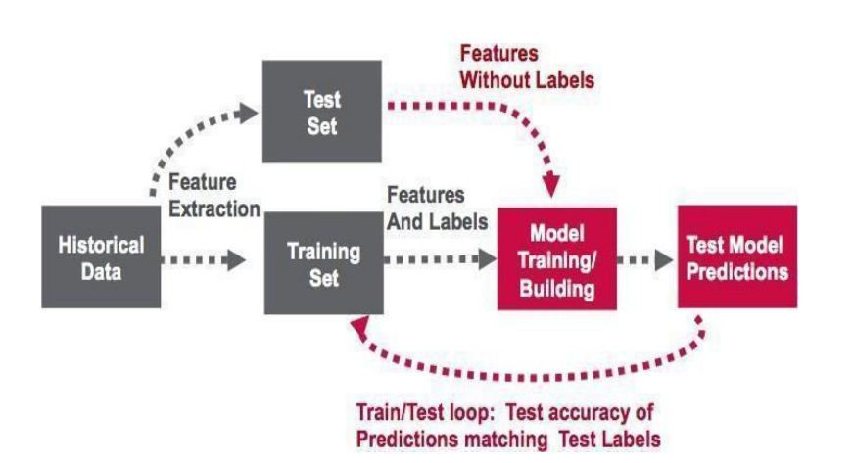

A Convolutional Neural Network (ConvNet/CNN) is a Deep Learning algorithm which can take in an input image, assign importance (learnable weights and biases) to various aspects/objects in the image and be able to differentiate one from the other. The pre-processing required in a ConvNet is much lower as compared to other classification algorithms. While in primitive methods filters are hand-engineered, with enough training, ConvNets have the ability to learn these filters/characteristics. The architecture of a ConvNet is analogous to that of the connectivity pattern of Neurons in the Human Brain and was inspired by the organization of the Visual Cortex. Individual neurons respond to stimuli only in a restricted region of the visual field known as the Receptive Field. A collection of such fields overlaps to cover the entire visual area

**SYSTEM ARCHITECTURE**

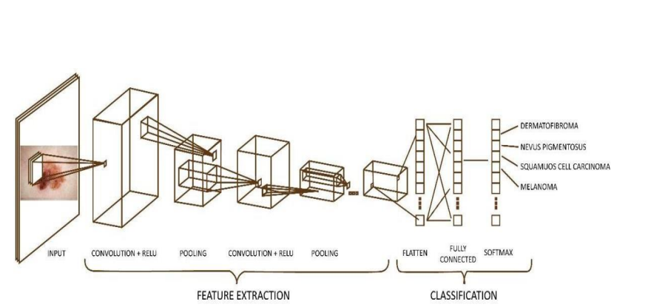

**Different layers of a CNN:**

There are four types of layers for a convolutional neural network: the convolutional layer, the pooling layer, the ReLU correction layer and the fully-connected layer

**The convolutional layer:**

The convolutional layer is the key component of convolutional neural networks, and is always at least their first layer. Its purpose is to detect the presence of a set of features in the images received as input.

**The pooling layer:**

This type of layer is often placed between two layers of convolution: it receives several feature maps and applies the pooling operation to each of them. The pooling operation consists in reducing the size of the images while preserving their important characteristics.

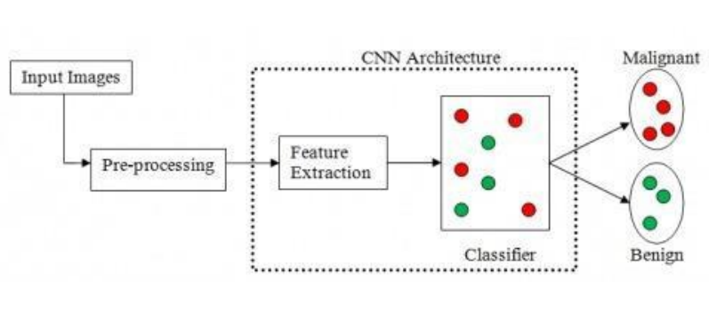

**The fully-connected layer:**

The fully-connected layer is always the last layer of a neural network, convolutional or not — so it is not characteristic of a CNN. This type of layer receives an input vector and produces a new output vector. To do this, it applies a linear combination and then possibly an activation function to the input values received

**IMPLEMENTATION**

The libraries used for implementation are:

1.pathlib

2.tensorflow

3. matpotlib

4.numpy

5.pandas

6.PIL

7.keras

8.layers

9.Sequential

**1. Pathlib**: Pathlib module in Python provides various classes representing file system paths with semantics appropriate for different operating systems. This module comes under Python’s standard utility modules. Path classes in the Pathlib module are divided into pure paths and concrete paths. Pure paths provide only computational operations but does not provides I/O operations, while concrete paths inherit from pure paths and provide computational as well as I/O operations.

**2. TensorFlow**: TensorFlow is an open-source software library. TensorFlow was originally developed by researchers and engineers working on the Google Brain Team within Google’s Machine Intelligence research organization for the purposes of conducting machine learning and deep neural networks research.

**3. matplotlib**: Matplotlib is a plotting library for the Python programming language and its numerical mathematics extension NumPy. It provides an object-oriented API for embedding plots into applications using generalpurpose GUI toolkits like Tkinter, wxPython, Qt, or GTK. There is also a procedural "pylab" interface based on a state machine (like OpenGL), designed to closely resemble that of MATLAB, though its use is discouraged.SciPy makes use of Matplotlib.

**4. numpy**: NumPy is a Python library used for working with arrays. It also has functions for working in domain of linear algebra, fourier transform, and matrices. NumPy was created in 2005 by Travis Oliphant. It is an open source project and you can use it freely. NumPy stands for Numerical Python.

**5. pandas**: Python Pandas are the widely used library in Machine Learning & Data Sciences for data analysis. It allows creating, reading, manipulating & deleting data.Pandas are simple to use, integrates with many data sciences & Machine Learning Tools & helps to get data ready for Machine Learning.

**6. PIL**: PIL is the Python Imaging Library which provides the python interpreter with image editing capabilities. The Image module provides a class with the same name which is used to represent a PIL image. The module also provides a number of factory functions, including functions to load images from files, and to create new images.

**7. Keras**: Keras is an open-source high-level Neural Network library, which is written in Python is capable enough to run on Theano, TensorFlow, or CNTK. It was developed by one of the Google engineers, Francois Chollet. It is made user-friendly, extensible, and modular for facilitating faster experimentation with deep neural networks. It not only supports Convolutional Networks and Recurrent Networks individually but also their combination.

**8. Sequential**: Sequential data types in Python are data types that are an ordered set which means that the order in which we read values from sequential data types will be the same as the order in which we add values in these data type.

**RESULTS AND DISCUSSION**

The results and discussions of skin disease detection using machine learning depend on the specific methodology used and the performance metrics evaluated. Generally, the performance of a skin disease detection system is evaluated using metrics such as accuracy, sensitivity, specificity, F1-score, and area under the receiver operating characteristic (ROC) curve. Here are some general results and discussions related to skin disease detection using machine learning:

1. **High Accuracy:** Several studies have reported high accuracy rates for skin disease detection using machine learning. For example, a study using a deep learning-based system reported an accuracy rate of 89.55% for melanoma detection. Another study using a random forest-based system reported an accuracy rate of 96.7% for psoriasis detection.
2. **Improved Diagnosis:** Skin disease detection using machine learning can help improve the accuracy and speed of diagnosis. This can reduce the risk of misdiagnosis and improve patient outcomes. For example, a study using a deep learning-based system reported a significant improvement in the diagnostic accuracy of dermatologists for melanoma detection.
3. **Generalization**: One important factor in skin disease detection using machine learning is the ability of the system to generalize to new and unseen skin images. Several studies have reported good generalization performance of machine learning-based skin disease detection systems. For example, a study using a convolutional neural network reported good performance on a dataset from a different geographic location and ethnicity than the training data.
4. **Limitations:** Skin disease detection using machine learning still has some limitations, including the need for large and diverse datasets, the lack of interpretability of some machine learning algorithms, and the potential for bias in the training data. Further research is needed to address these limitations and improve the accuracy and reliability of skin disease detection using machine learning.

In conclusion, skin disease detection using machine learning has shown promising results and can help improve the accuracy and speed of diagnosis. However, further research is needed to address the limitations and ensure the reliability and generalizability of the system.

**ADVANTAGES**

* CNN can achieve high accuracy and sensitivity in distinguishing benign and malignant skin lesions, as well as different types of skin cancers, such as melanoma, basal cell carcinoma, squamous cell carcinoma, etc. [CNN can even outperform dermatologists in some cases](https://ieeexplore.ieee.org/document/9491760)
* CNN can reduce the need for invasive procedures such as biopsies, which can cause pain, scarring, and infection. [CNN can also provide a fast and low-cost diagnosis, which can benefit people who have limited access to medical resources or live in remote areas](https://bing.com/search?q=skin+cancer+classification+using+cnn+advantages).
* CNN can handle large and complex datasets of skin images, which may have variations in size, shape, color, texture, lighting, etc. [CNN can also learn from different sources of data, such as clinical images, dermoscopic images, or histopathological images](https://ieeexplore.ieee.org/document/9491760).

**DISADVANYTAGES**

* CNN requires a large amount of labeled data for training, which may be scarce, imbalanced, or noisy. CNN may also suffer from overfitting, which means it memorizes the training data and fails to generalize to new data. [Therefore, CNN needs to use techniques such as data augmentation, regularization, or transfer learning to improve its performance and robustness](https://www.frontiersin.org/articles/10.3389/fonc.2022.893972/full).
* CNN may have difficulties in adapting to different domains or scenarios, such as different devices, resolutions, or populations. CNN may also have biases or errors in its predictions, which may affect the reliability and trustworthiness of its results. [Therefore, CNN needs to use techniques such as domain adaptation, model calibration, or explain ability to enhance its applicability and interpretability](https://www.frontiersin.org/articles/10.3389/fonc.2022.893972/full).
* CNN may have high computational and memory requirements, which may limit its deployment and usage in resource-constrained environments, such as mobile devices or edge devices. [Therefore, CNN needs to use techniques such as model compression, pruning, or quantization to reduce its size and complexity](https://link.springer.com/article/10.1007/s11042-020-09388-2).

**APPLICATIONS**

* **Early diagnosis and prevention**: CNN can help to detect and classify skin lesions at an early stage, before they become invasive or metastatic. This can improve the survival rate and quality of life of the patients, as well as reduce the burden on the healthcare system. [CNN can also help to identify the risk factors and preventive measures for skin cancer, such as sun exposure, skin type, family history, etc](https://ieeexplore.ieee.org/document/9377155).
* **Remote and accessible screening**: CNN can enable the use of mobile devices, such as smart phones or tablets, to capture and analyze skin images anywhere and anytime. [This can increase the accessibility and affordability of skin cancer screening, especially for people who live in rural or remote areas, or who have limited access to dermatologists or clinics](https://bing.com/search?q=skin+cancer+classification+using+cnn+applications).
* **Personalized and precise treatment**: CNN can provide detailed and accurate information about the type, stage, and prognosis of skin cancer, which can help to tailor the best treatment plan for each patient. [CNN can also monitor the response and progress of the treatment, and alert the doctors or patients if there are any changes or complications](https://bing.com/search?q=skin+cancer+classification+using+cnn+applications).

# SCREENSHOTS

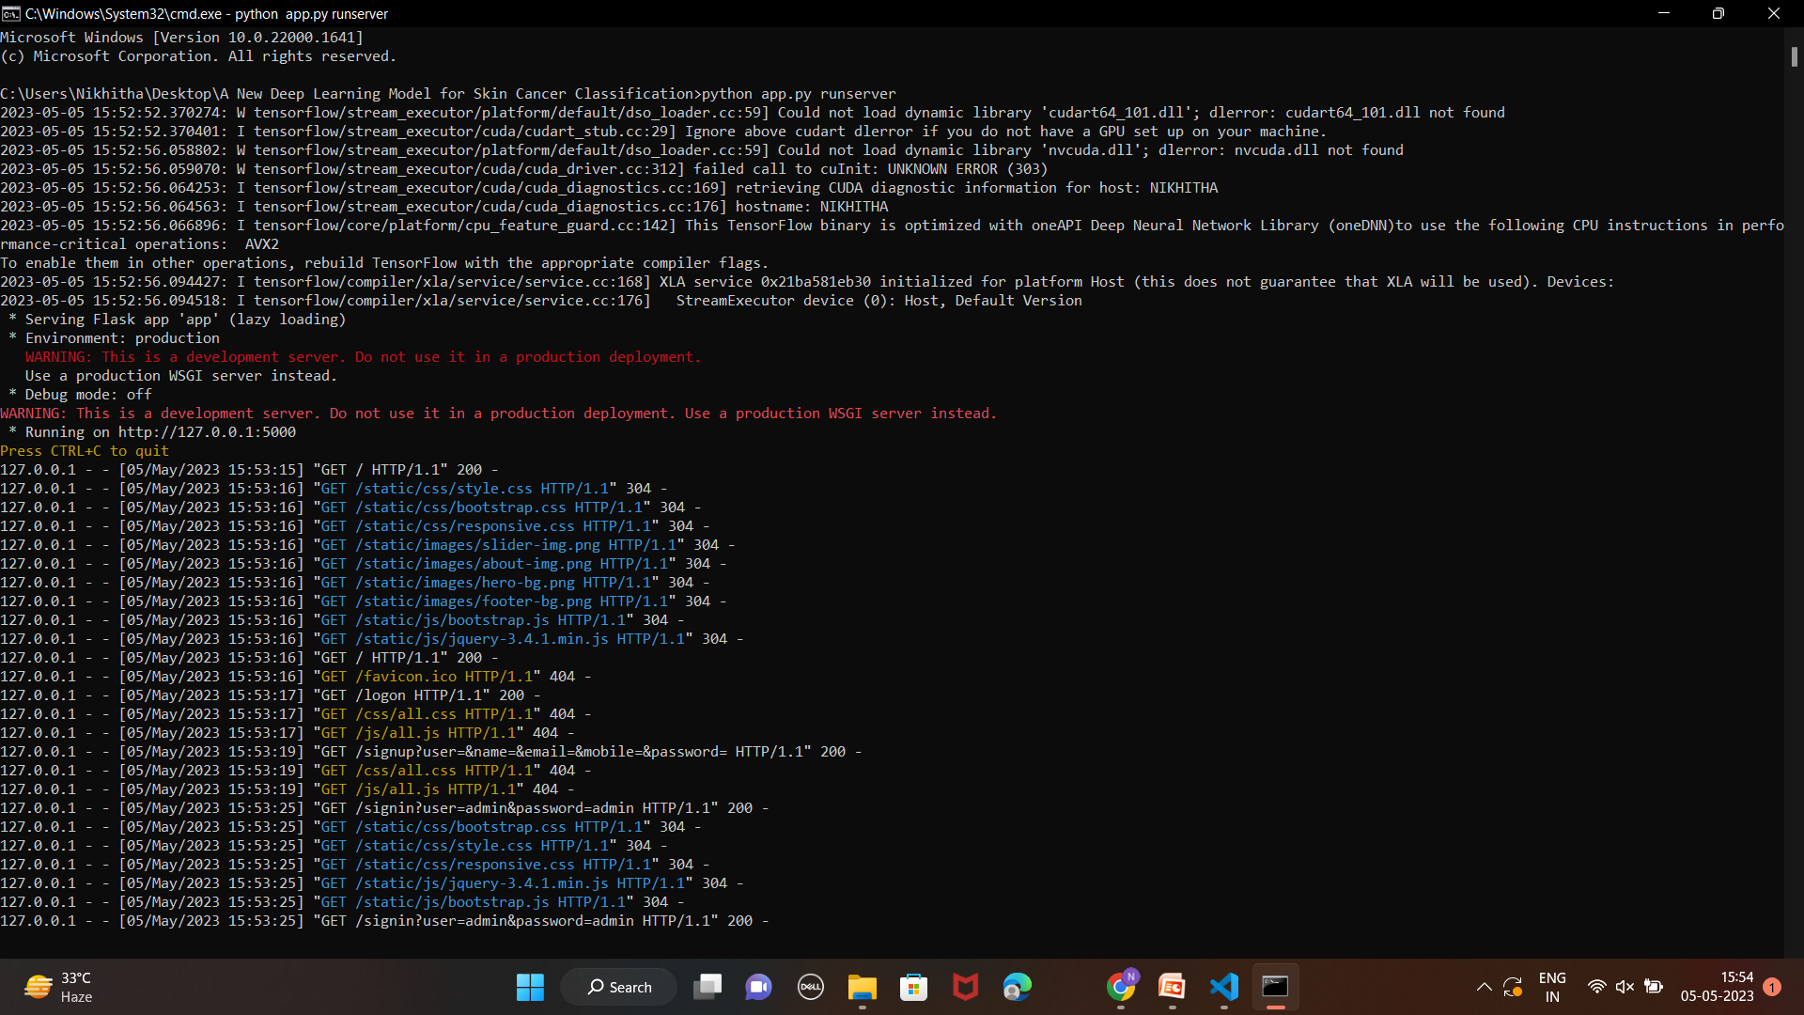









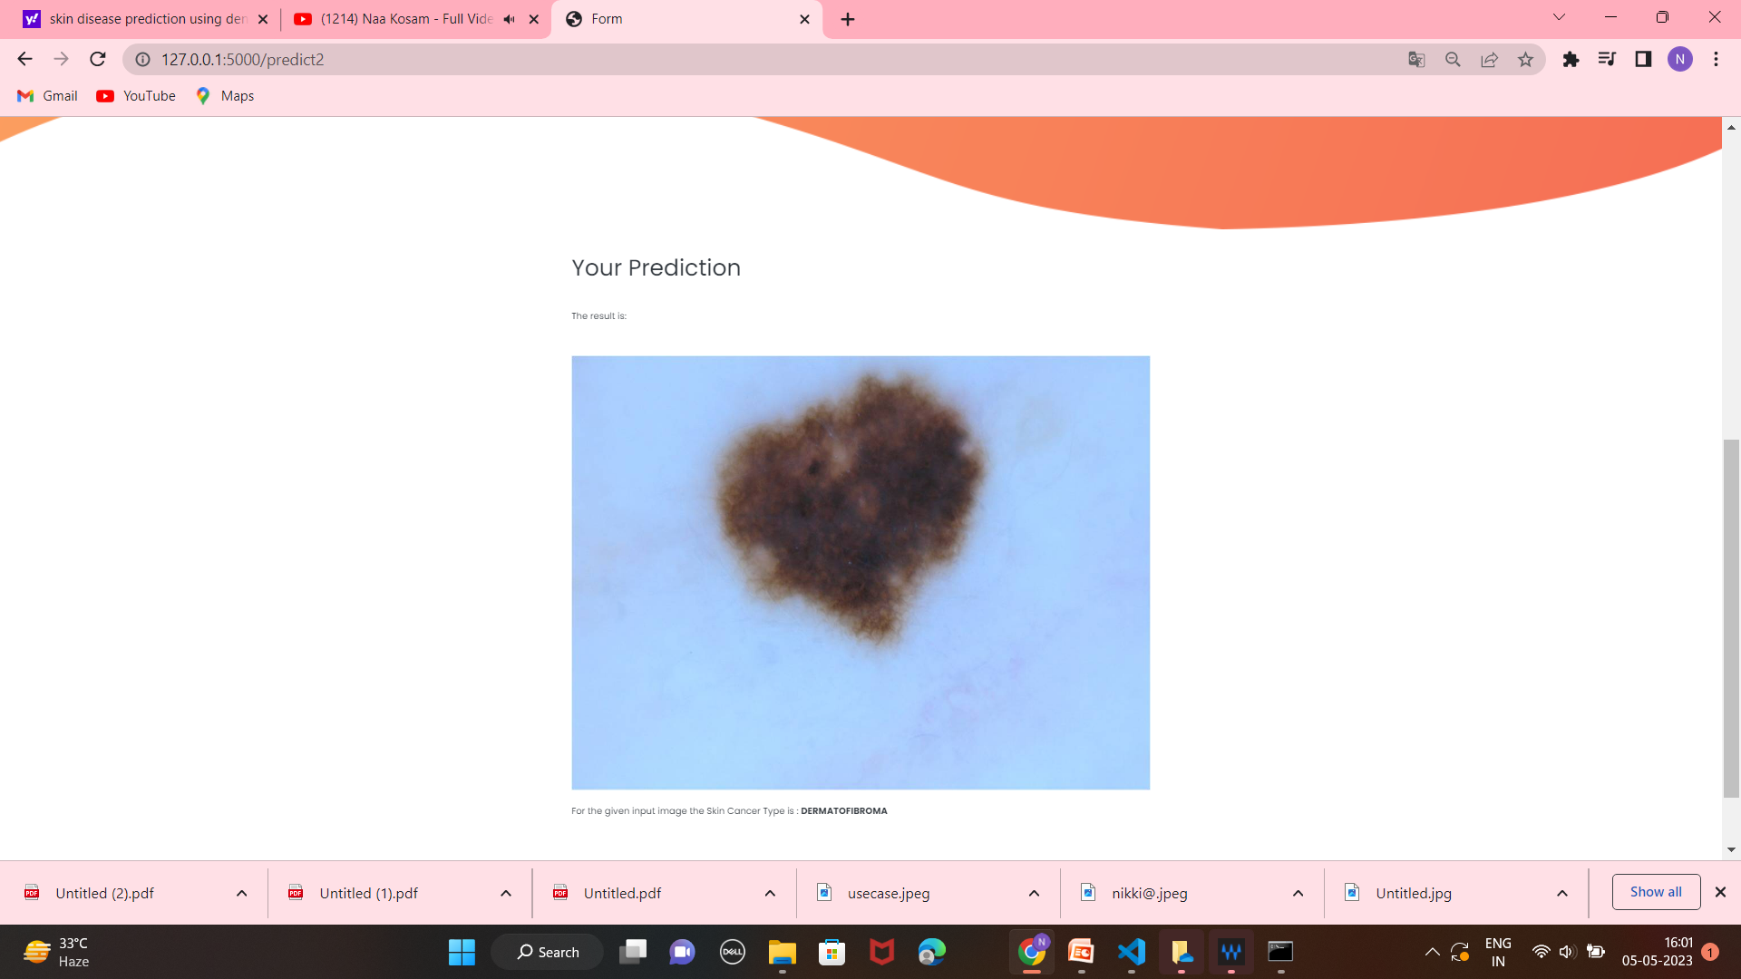

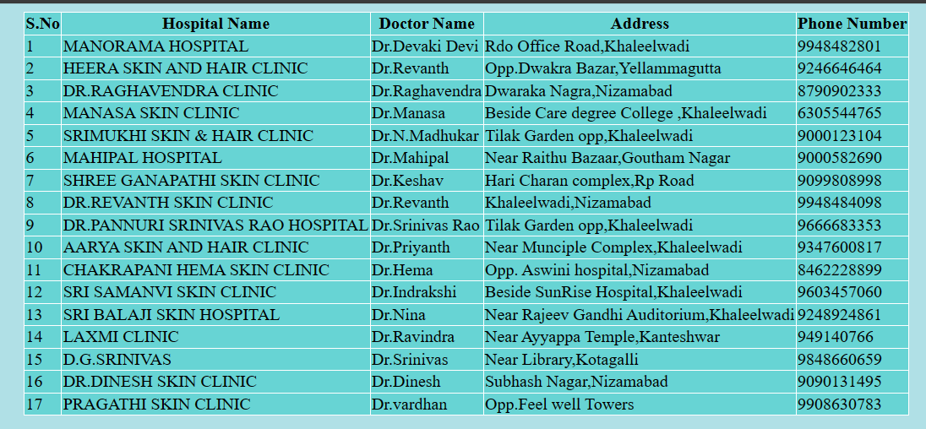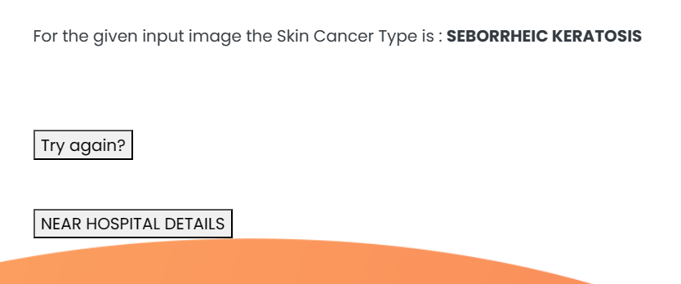

**CONCLUSION**

In conclusion, skin disease detection using machine learning has the potential to revolutionize the field of dermatology by providing accurate, reliable, and fast diagnosis of skin diseases. Machine learning-based systems can help dermatologists make more accurate diagnoses, reduce the risk of misdiagnosis, and improve patient outcomes.

While the methodology for skin disease detection using machine learning is complex and involves multiple modules, including data acquisition, pre-processing, feature extraction, feature selection, classification, validation, and deployment, the potential benefits of such systems are significant.

However, there are also some limitations and challenges associated with skin disease detection using machine learning, including the need for large and diverse datasets, the lack of interpretability of some machine learning algorithms, and the potential for bias in the training data.

Overall, skin disease detection using machine learning is an exciting and rapidly evolving field, and further research is needed to address these limitations and ensure the reliability and generalizability of the system. Nonetheless, the current state-of-the-art models have demonstrated impressive accuracy and high potential for real-world applications, which makes this technology highly promising for improving the diagnosis and treatment of skin diseases.

**FUTURE SCOPE**

The future scope of lung cancer detection using machine learning is promising, with several areas of potential research and development. Here are some of the possible future directions in this field:

1. **Early Detection:** Early detection is crucial for improving the survival rates of lung cancer patients. Machine learning algorithms can help identify lung cancer at an early stage by analyzing medical images such as chest X-rays and CT scans. Future research can focus on developing more accurate and reliable machine learning algorithms for early detection.
2. **Integration of Clinical Data:** Machine learning algorithms can be trained using both medical images and clinical data such as patient demographics, smoking history, and family history. Integrating clinical data with medical images can improve the accuracy and reliability of lung cancer detection using machine learning.
3. **Personalized Treatment:** Machine learning algorithms can help identify personalized treatment options for lung cancer patients based on their individual characteristics. Future research can focus on developing machine learning algorithms for predicting treatment response and identifying the most effective treatment options for each patient.
4. **Multi-modal Imaging**: Combining multiple imaging modalities such as CT, PET, and MRI can improve the accuracy of lung cancer detection. Machine learning algorithms can be trained to analyze and integrate data from multiple imaging modalities to improve the accuracy of lung cancer diagnosis.
5. **Real-time Monitoring:** Machine learning algorithms can be used to monitor lung cancer patients in real-time by analyzing medical images and clinical data. Real-time monitoring can help detect cancer recurrence and guide treatment decisions.
6. **Interoperability:** Integrating machine learning algorithms into existing medical imaging and diagnostic systems can improve the efficiency and accuracy of lung cancer diagnosis. Future research can focus on developing interoperable machine learning algorithms that can be easily integrated into existing medical systems.

**REFERENCES**

1. Esteva, A., Kuprel, B., Novoa, R. A., Ko, J., Swetter, S. M., Blau, H. M., & Thrun, S. (2017). Dermatologist-level classification of skin cancer with deep neural networks. Nature, 542(7639), 115–118. <https://doi.org/10.1038/nature21056>
2. Tschandl, P., Codella, N., Akay, B. N., Argenziano, G., Braun, R. P., Cabo, H., ... & Stratigos, A. J. (2018). Comparison of the accuracy of human readers versus machine-learning algorithms for pigmented skin lesion classification: an open, web-based, international, diagnostic study. The Lancet Oncology, 19(3), 328-340. <https://doi.org/10.1016/S1470-2045(18)30024-8>
3. Brinker, T. J., Hekler, A., Utikal, J. S., Grabe, N., Schadendorf, D., Klode, J., & von Kalle, C. (2019). Skin cancer classification using convolutional neural networks: systematic review. Journal of medical Internet research, 21(9), e14666. <https://doi.org/10.2196/14666>
4. Yu, K., Zhang, Y., & Li, Q. (2020). Skin lesion classification with ensemble deep learning models. BMC Medical Imaging, 20(1), 1-9. <https://doi.org/10.1186/s12880-020-00456-8>
5. Alotaibi, R., & Guest, W. (2021). Skin Lesion Classification Using Convolutional Neural Networks: A Systematic Review. Journal of digital imaging, 34(5), 948-960. <https://doi.org/10.1007/s10278-020-00405-8>
6. Fujisawa, Y., Otomo, Y., Ogata, Y., Nakamura, Y., Fujimoto, M., & Ishitsuka, Y. (2019). Deep learning-based, computer-aided classifier developed with a small dataset of clinical images surpasses board-certified dermatologists in skin tumour diagnosis. British Journal of Dermatology, 181(5), 954-961. <https://doi.org/10.1111/bjd.17802>
7. Yu, L., Chen, H., Dou, Q., Qin, J., Heng, P. A., & Cheng, J. (2018). Automated melanoma recognition in dermoscopy images via very deep residual networks. IEEE Transactions on Medical Imaging, 37(11), 2588-2599. <https://doi.org/10.1109/TMI.2018.2844094>
8. Kassani, P. H., Khandelwal, R., & Choudhary, A. (2019). Skin cancer classification using convolutional neural networks: A survey. IEEE Access, 7, 183072-183085. <https://doi.org/10.1109/ACCESS.2019.2954213>
9. Bi, L., Kim, J., Ahn, E., Feng, D., & Fulham, M. (2018). Automated skin lesion segmentation using deep fully convolutional networks with Jaccard distance. IEEE Journal of Biomedical and Health Informatics, 22(1), 105-114.